Setting up dual myo streaming

5/5/2016

Armiger

Start VirtualBox

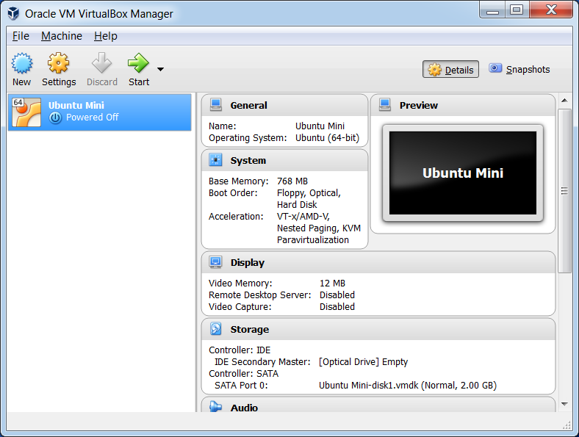

Start Ubuntu Mini and login vradmin. Standard VR Password

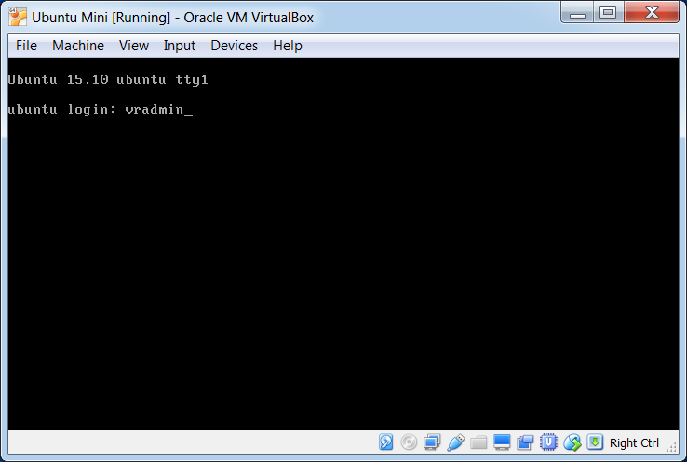

Enter > hcitool dev and ensure 2 adapters are found. If they are not found, unplug both adapters and replug them. May have to try different USB ports, but both should be detected.

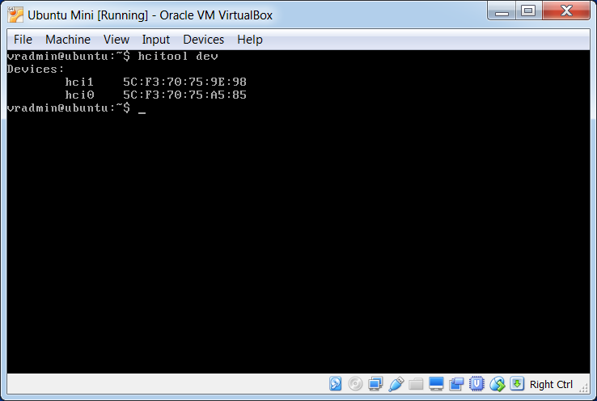

Start the streaming program as admin

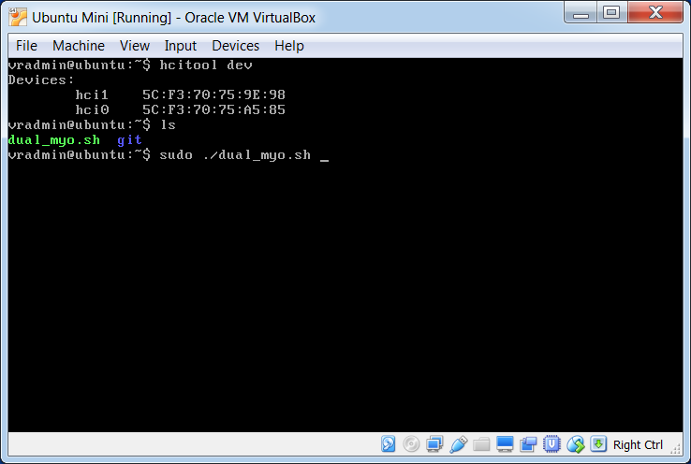

As the program starts, ensure the Myos are awake (shake them is necessary)

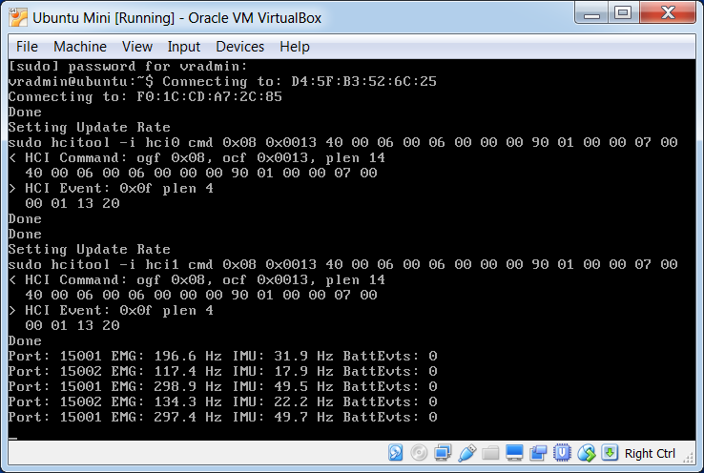

Ensure that the streaming rate on both ports [15001 and 15002] are stabilized at 300Hz. Retry if not

In the MiniVIE, ensure that the configuration file loaded specifies EMG from source" 15001. 15002

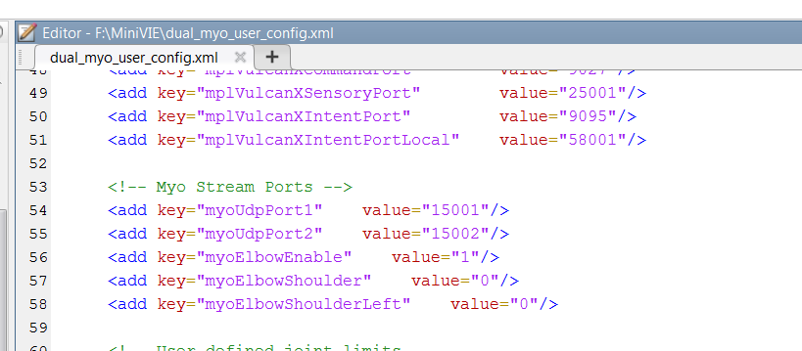

In the MiniVIE Signal Viewer, ensure data is being streamed from both Myos (Ch 1-8 for Myo 1 and Ch 9-16 for Myo 2). Also ensure that the data is appearing at the same rate for both channels sets. If the high rate bluetooth streaming is not established (at 300Hz) this will cause downstream problems for the arm system

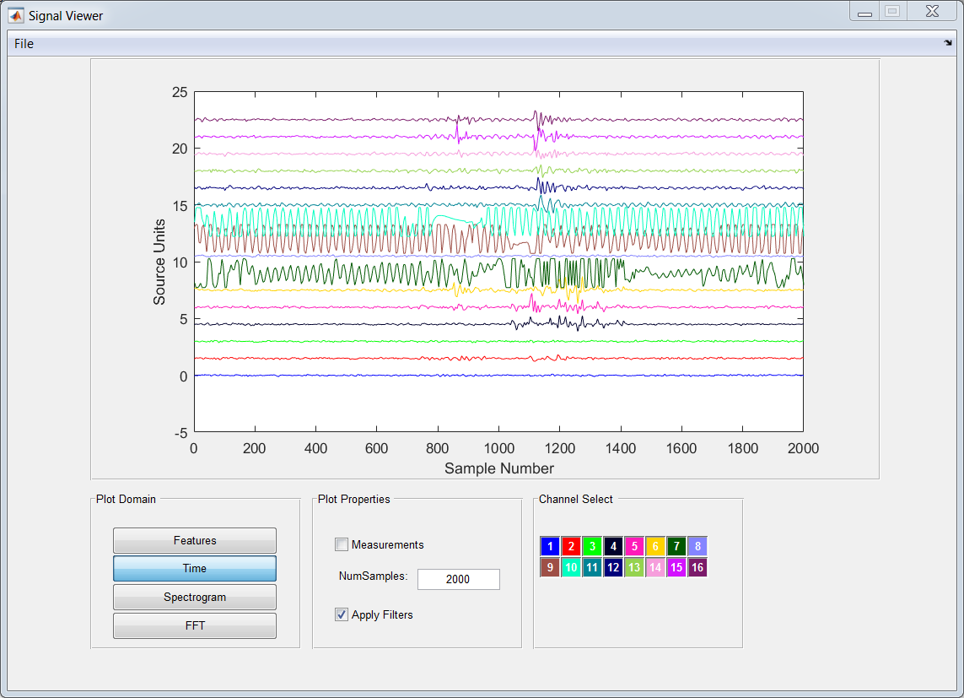

To cleanup, connect a USB cable to each myo to break the stream (and charge). Power off the virtual machine